**CODELAB 1 SIMPLE REFACTORING**

**Module:** Advanced Programming – Module 2 (Simple Refactoring)  
**Name:** Ovan Keyva Kusumadewa  
**NIM:** 202410370110506

**1. Objective**

The objective of this codelab is to apply several refactoring techniques to improve the structure, readability, and maintainability of a simple Library Management program without changing its original behavior.

**2. Tools and Preparation**

* **Programming Language:** Java
* **IDE:** IntelliJ IDEA / NetBeans
* **JDK Version:** 17+
* **Concepts Used:** Object-Oriented Programming (Encapsulation, Constants, Methods)

**3. Refactoring Concepts Applied**

* In this codelab, the following refactoring techniques were applied:

|  |  |  |
| --- | --- | --- |
| **No** | **Refactoring Technique** | **Purpose** |
| 1 | Encapsulate Field | Protect class attributes by using getters and setters instead of public fields. |
| 2 | Introduce Constant | Replace magic numbers with named constants for clarity. |
| 3 | Extract Method | Separate discount calculation logic into its own reusable method. |
| 4 | Move Method | Move the main() method from MainApp to a new Main class for better structure. |

**4. Refactoring**

* Book.java

Before:

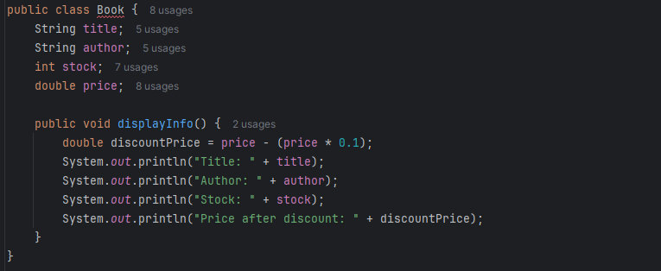

After:

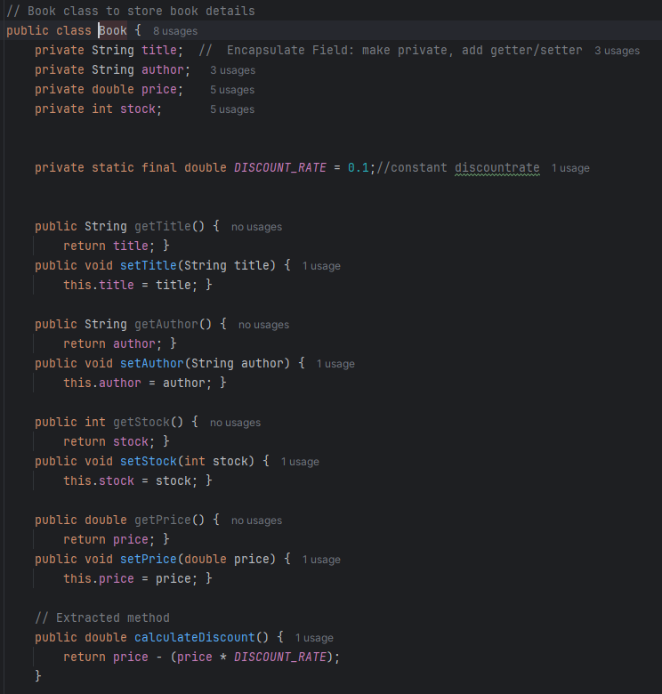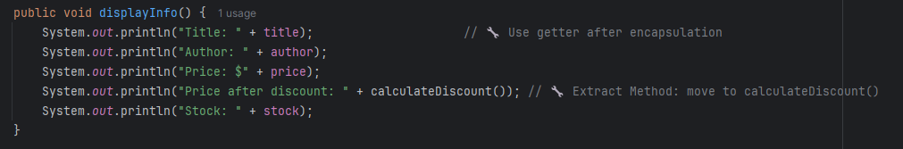

* Library.java

Before:

After: 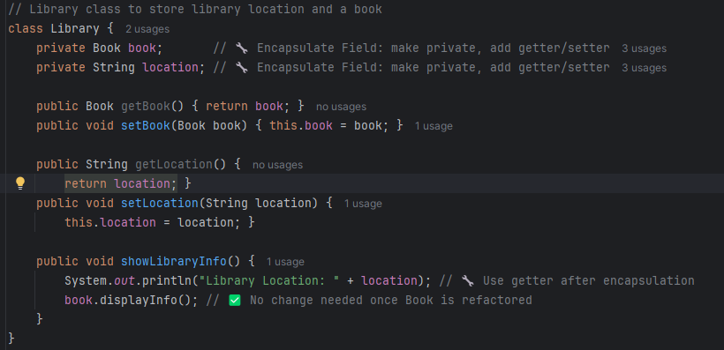

* MainApp.java

Before: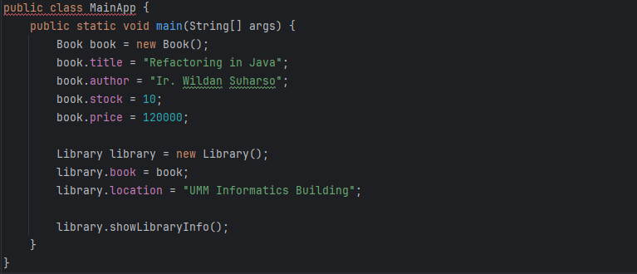After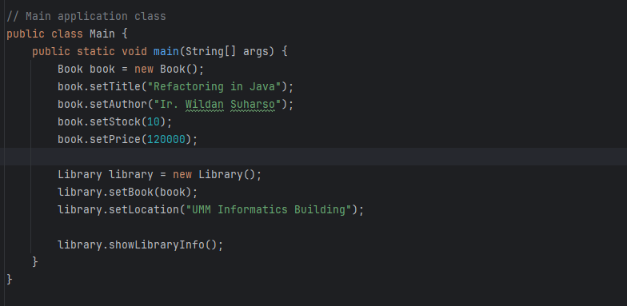

**5. Output**

**6. Conclusion**

Through this codelab, several refactoring techniques were successfully implemented to enhance the structure, readability, and maintainability of the Library Management code.

The final version:

* Eliminates direct access to class fields.
* Uses constants for clarity.
* Separates logic into smaller, focused methods.
* Follows better project organization with a dedicated Main class.